***SET – 04***

* MOSFET AS A SWITCH:

MOSFET (Metal Oxide Semiconductor Field Effect Transistor), is a three terminal transistor consisting of the gate, drain and source terminals.

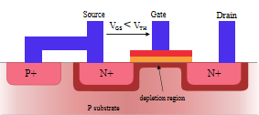

A cross-section through an n MOSFET when the gate voltage VGS is below the threshold for making a conductive channel; there is little or no conduction between the terminals drain and source; the switch is OFF.

When the gate is more positive, it attracts electrons, inducing an n-type conductive channel in the substrate below the oxide, which allows electrons to flow between the n-doped terminals; the switch is ON.

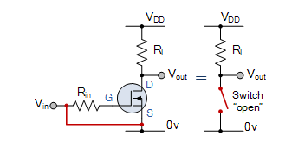

How any MOSFET would work can be easily known from its characteristics curve and the load line. So first let us study about the characteristics curve and the load line.

MOSFET Characteristics Curve:

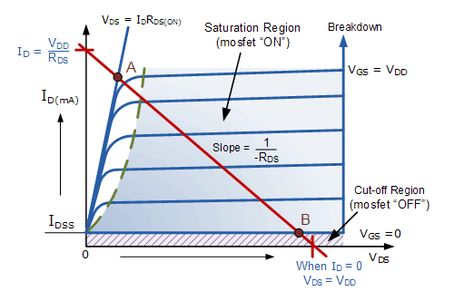

As seen from the above diagram, there are three operating zones in a MOSFET: 1. Active

2. Saturation and

3. Cut off region.

Similar to your normal BJT, a MOSFET is ON in the Saturation region and OFF in the Cut Off region.

Cut off Characteristics:

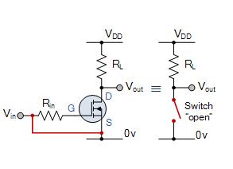

* The input and Gate are grounded ( 0V )
* Gate-source voltage less than threshold voltage VGS < VTH
* MOSFET is “OFF” ( Cut-off region )
* No Drain current flows ( ID = 0 Amps )
* VOUT = VDS = VDD = ”1″
* MOSFET operates as an “open switch” and hence OFF.

Here the operating conditions of the transistor are zero input gate voltage ( VIN ), zero drain current ID and output voltage VDS = VDD. Therefore for an enhancement type MOSFET the conductive channel is closed and the device is switched “OFF”.

Then we can define the cut-off region or “OFF mode” when using an e-MOSFET as a switch as being, gate voltage, VGS < VTH and ID = 0. For a P-channel enhancement MOSFET, the Gate potential must be more positive with respect to the Source.

Saturation Characteristics:

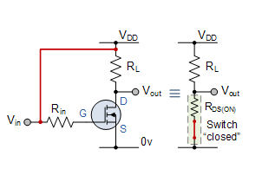

* The input and Gate are connected to VDD
* Gate-source voltage is much greater than threshold voltage VGS > VTH
* MOSFET is “ON” ( saturation region )
* Max Drain current flows ( ID = VDD / RL )
* VDS = 0V (ideal saturation)
* Min channel resistance RDS(on) < 0.1Ω
* VOUT = VDS ≅ 0.2V due to RDS(on)
* MOSFET operates as a low resistance “closed switch”

Then we can define the saturation region or “ON mode” when using an e-MOSFET as a switch as gate-source voltage, VGS > VTH and ID = Maximum. For a P-channel enhancement MOSFET, the Gate potential must be more negative with respect to the Source.

By applying a suitable drive voltage to the gate of an FET, the resistance of the drain-source channel, RDS(on) can be varied from an “OFF-resistance” of many hundreds of kΩ, effectively an open circuit, to an “ON-resistance” of less than 1Ω, effectively acting as a short circuit.

When using the MOSFET as a switch we can drive the MOSFET to turn “ON” faster or slower, or pass high or low currents. This ability to turn the power MOSFET “ON” and “OFF” allows the device to be used as a very efficient switch with switching speeds much faster than standard bipolar junction transistors.

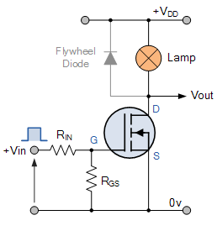

In this circuit arrangement an Enhancement-mode N-channel MOSFET is being used to switch a simple lamp “ON” and “OFF” (could also be an LED).

The gate input voltage VGS is taken to an appropriate positive voltage level to turn the device and therefore the lamp load either “ON”, ( VGS = +ve ) or at a zero voltage level that turns the device “OFF”, ( VGS = 0V ).

If the resistive load of the lamp was to be replaced by an inductive load such as a coil, solenoid or relay a “flywheel diode” would be required in parallel with the load to protect the MOSFET from any self generated back-emf.

Above shows a very simple circuit for switching a resistive load such as a lamp or LED. But when using power MOSFETs to switch either inductive or capacitive loads some form of protection is required to prevent the MOSFET device from becoming damaged. Driving an inductive load has the opposite effect from driving a capacitive load.

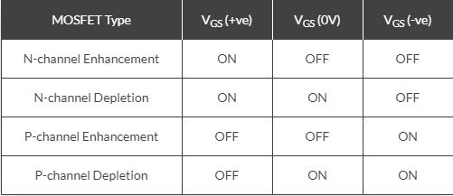

PNEUMATIC SOLENOIDS:

Available on www.pneumadyne.com

A solenoid valve is an efficient method of converting electrical signals into pneumatic functions. Applying electricity to the solenoid quickly directs air through the valve and into the circuit.

There are many different names and types available and they also come in as sorts of sizes.

Solenoid Valve is an electromechanically operated valve. When current passes through solenoid, it opens the valve and fluid/air passes through the small orifice.

There are two types:

2Port valve; where the flow is switched either ON or OFF.

3Port valve; where the outflow is switched between the two outlet ports.

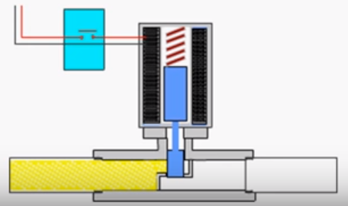

In such a solenoid valve, we have a solenoid which wraps a magnetic piston. The piston in turn covers the orifice and has a spring on its top to get back to the equilibrium once the work is done.

The above given picture is the equilibrium position where the fluid stays in the left hand side of the piston with the piston blocking its way.

Once the switch is closed, that is, current is made to pass through the solenoid, due to magnetic induction, there is movement in the piston.

The movement is an upward movement and hence the piston moves upwards.

So a small bit of space is created for the fluid to flow to the right hand side.

After the switch is turned OFF, the piston returns back to its original position and the fluid gets blocked again.

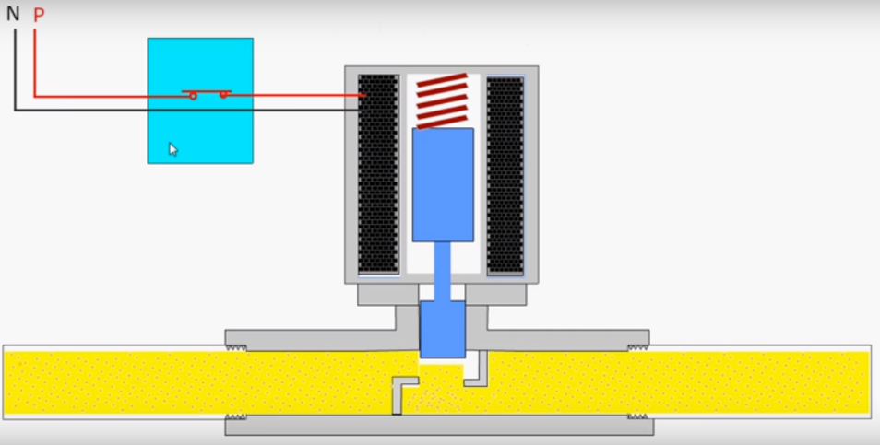

Applications:

* Solenoid valves are used in fluid pneumatic and hydraulic systems, to control cylinders, fluid power motors or larger industrial valves.
* Automatic irrigation sprinkler systems also use solenoid valves with an automatic controller.
* Used very heavily in textile and robotics.
* Domestic dishwasher and washing machines also use solenoid valves to control entry into the machines.
* Solenoid valves are used in dental chairs to control the air and water flow.
* In the paintball industry, solenoid valves are usually referred to simply ‘solenoids’. They are commonly used to control a larger valve used to control the propellant.

A basic solenoid valve is available online for about Rs.500-1000.

### Choose a Solenoid valve according to your needs: 10 mm Solenoid Valves

This [miniature solenoid valve](https://www.pneumadyne.com/solenoid-valves/way-normally-closed-solenoid-valves-c-77_89.html) has an overall length of 1.08” and height of .52” making it the ideal choice for applications where space is limited. Our 2 Way and 3 Way solenoid valves feature three connector options, leads, and plug-in connectors, to simplify installation. This versatile pneumatic solenoid valve offering includes 12 & 24 Volt DC and a low watt 24 Volt DC.

### 15 mm Solenoid Valves

A [15 mm direct acting solenoid valve](https://www.pneumadyne.com/pneumatic-solenoid-valves-normally-closed-solenoid-valves-c-1_77_89-l-en.html) features a variety of connector, electrical, and mounting options to accommodate a variety of system requirements. 2 way and 3 way solenoid valves are offered with 12 Volt DC, 24 Volt DC, and 110 Volt AC coils. Three orifice diameters (0.8 mm, 1.1 mm, and 1.6 mm) are available to fit flow rates to your application specifications.

### System 6 Solenoid Valves

Pneumadyne’s [System 6 solenoid valve](https://www.pneumadyne.com/pneumatic-solenoid-valves-normally-closed-solenoid-valves-c-1_77_89-l-en.html) features a wide variety of voltage options, including a low watt version (0.8 watt) that is ideal for low power control circuits. These 2 Way and 3 Way Normally Closed solenoid valves are available with Spade and Flying Leads Connectors for fast electrical connection.

### System 8 Solenoid Valves

The [system 8 solenoid valve](https://www.pneumadyne.com/pneumatic-solenoid-valves-normally-closed-solenoid-valves-c-1_77_89-l-en.html) features a larger orifice for applications requiring higher flow rates, 6.2 to 9.0 scfm at 125 psi. These 2 Way and 3 Way solenoid valves are offered with a Spade Connector and 12 Volt DC, 24 Volt DC, 110 Volt AC, and 220 Volt AC coils to accommodate your fluid handling requirements.

### Latching Solenoid Valves

A [latching solenoid valve](https://www.pneumadyne.com/solenoid-valves/latching-solenoid-valve-c-77_103.html) is recommended for applications where power is limited or coil heating is unwanted; continuous power is not required to maintain the energized position. The 15 mm solenoid valve option features a 3-wire system, therefore, a relay is not required to reverse polarity. Fast response times allow for a momentary pulse to energize and de-energize the valves.

### Manifolds & Bases

Pneumadyne [manifolds](http://www.pneumadyne.com/pneumatic-solenoid-valves-solenoid-bases-manifolds-c-1_77_104-l-en.html) are a cost effective solution for mounting multiple solenoid valves. Single to 12-station manifolds are available with a 10-32 (F), M5 (F), 1/8 NPT (F) or ¼ NPT (F) threads for plumbing convenience. All bases and manifolds are clear anodized for corrosion resistance.  
   
When used in conjunction with our bases and manifolds, a Pneumadyne solenoid valve is the ideal interface between your pneumatic and electrical systems.  
 

* STEP UP AND STEP DOWM RESISTORS:

1. Step Up Resistors:

Pull-up resistors are very common when using microcontrollers (MCUs) or any digital logic device. This tutorial will explain when and where to use pull-up resistors, then we will do a simple calculation to show why pull-ups are important.

## What is a Pull-up Resistor

Let’s say you have an MCU with one pin configured as an input. If there is nothing connected to the pin and your program reads the state of the pin, will it be high (pulled to VCC) or low (pulled to ground)? It is difficult to tell. This phenomena is referred to as floating. To prevent this unknown state, a pull-up or pull-down resistor will ensure that the pin is in either a high or low state, while also using a low amount of current.

For simplicity, we will focus on pull-ups since they are more common than pull-downs. They operate using the same concepts, except the pull-up resistor is connected to the high voltage (this is usually 3.3V or 5V and is often referred to as VCC) and the pull-down resistor is connected to ground.

Pull-ups are often used with buttons and switches.

[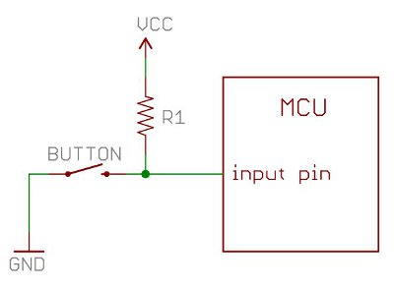](https://cdn.sparkfun.com/assets/6/f/b/c/7/511568b6ce395f1b40000000.jpg)

With a pull-up resistor, the input pin will read a high state when the button is not pressed. In other words, a small amount of current is flowing between VCC and the input pin (not to ground), thus the input pin reads close to VCC. When the button is pressed, it connects the input pin directly to ground. The current flows through the resistor to ground, thus the input pin reads a low state. Keep in mind, if the resistor wasn’t there, your button would connect VCC to ground, which is very bad and is also known as a short.

So what value resistor should you choose?

The short and easy answer is that you want a resistor value on the order of 10kΩ for the pull-up.

**A low resistor value is called a strong pull-up (more current flows), a high resistor value is called a weak pull-up (less current flows).**

[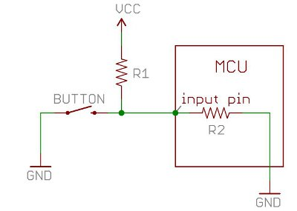](https://cdn.sparkfun.com/assets/f/1/4/a/b/511568b7ce395f613f000004.jpg)

The value of the pull-up resistor needs to be chosen to satisfy two conditions:

1. When the button is pressed, the input pin is pulled low. The value of resistor R1 controls how much current you want to flow from VCC, through the button, and then to ground.
2. When the button is not pressed, the input pin is pulled high. The value of the pull-up resistor controls the voltage on the input pin.

For condition 1, you don’t want the resistor’s value too low. The lower the resistance, the more power will be used when the button is hit. You generally want a large resistor value (10kΩ), but you don’t want it too large as to conflict with condition 2. A 4MΩ resistor might work as a pull-up, but its resistance is so large (or weak) that it may not do its job 100% of the time.

The general rule for condition 2 is to use a pull-up resistor (R1) that is an order of magnitude (1/10th) less than the input impedance (R2) of the input pin. An input pin on a microcontroller has an impedance that can vary from 100k-1MΩ. For this discussion, impedance is just a fancy way of saying resistance and is represented by R2 in the picture above. So, when the button is not pressed, a very small amount of current flows from VCC through R1 and into the input pin. The pull-up resistor R1 and input pin impedance R2 divides the voltage, and this voltage needs to be high enough for the input pin to read a high state.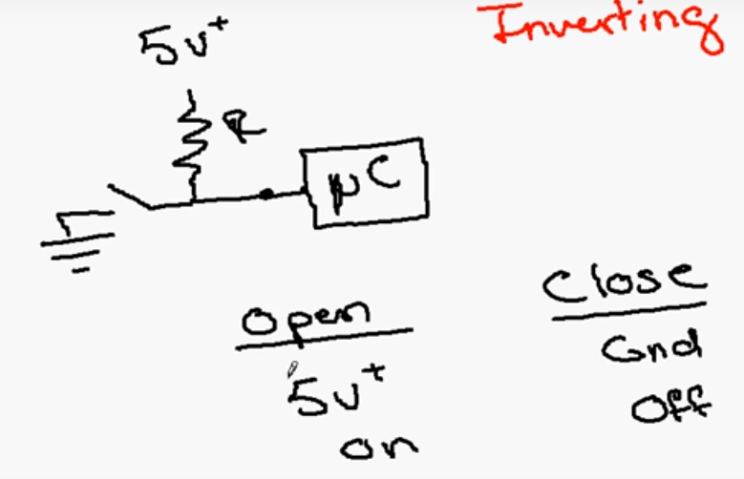

2. Pull Down Resistors:

A pull down resistor works in the opposite way as the pull up does.

When we leave the switch open, the microcontroller will be OFF as all the floating voltage is grounded through the resistor.

Whilst, when the switch is close, all the current flows directly to the microcontroller and hence it turns ON.

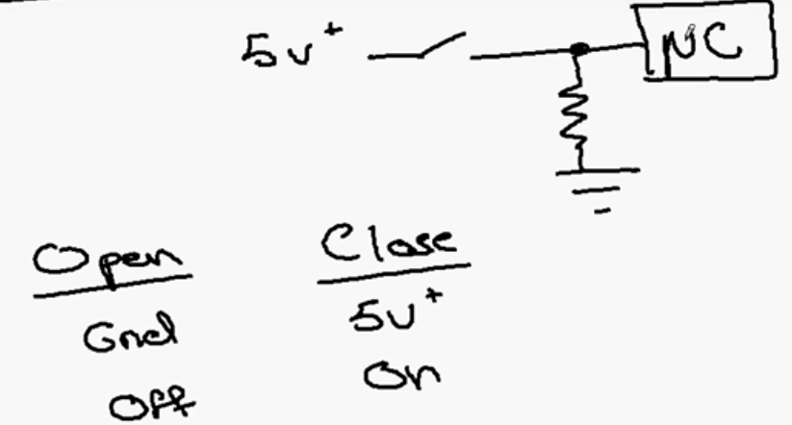

Unlike the pull up resistor, pull down resistor is not built along with some microcontrollers.

They can be installed in a similar way as shown in the above diagram.

* TFETs(A replacement to MOSFET):

The tunnel field-effect transistor (TFET) is an experimental type of transistor. Even though its structure is very similar to a metal-oxide-semiconductor field-effect (MOSFET), the fundamental switching mechanism differs, making this device a promising candidate for low power electronics.

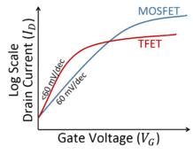

STRUCTURE:

The basic TFET structure is similar to a MOSFET except that the source and drain terminals of a TFET are doped of opposite type (see figure). A common TFET device structure consists of a P-I-N (p-type, intrinsic, n-type) junction, in which the electrostatic potential of the intrinsic region is controlled by a gate terminal.

OPERATION:  
The device is operated by applying gate bias so that electron accumulation occurs in the intrinsic region. At sufficient gate bias, band-to-band tunneling (BTBT) occurs when the conduction band of the intrinsic region aligns with the valence band of the P region. Electrons from the valence band of the p-type region tunnel into the conduction band of the intrinsic region and current can flow across the device. As the gate bias is reduced, the bands becomes misaligned and current can no longer flow.

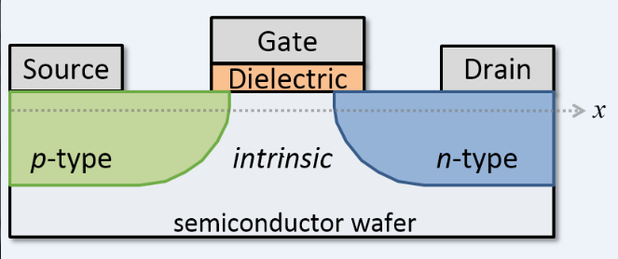

ADVANTAGES OVER MOSFET:

Suitable for low power application because of the lower leakage current.

SS lower than conventional limit of 60 mV/dec.

Conduction in TFET depends on the band bending in the small tunnel region, but not in the whole channel.

CHALLENGES:

The drive current is relatively low as compared to MOSFET.

Dopant abruptness less than 4nm/dec is needed to maximize the junction electric fields and enable high on-currents.

Suppression of Ambipolar Behavior by underlapped drain//lower the doping on the drain side// small bandgap material in the source and larger bandgap material in the channel and the drain (Heterojunction).